Define S-Web's 60,000 Times Faster Claim
16.22b.3)__Define_S-Web's_60,000 Times_Faster_Claim_(8_Mar_2023)
By Nick Ray Ball

Wednesday – 11.30 GMT – March 08, 2023

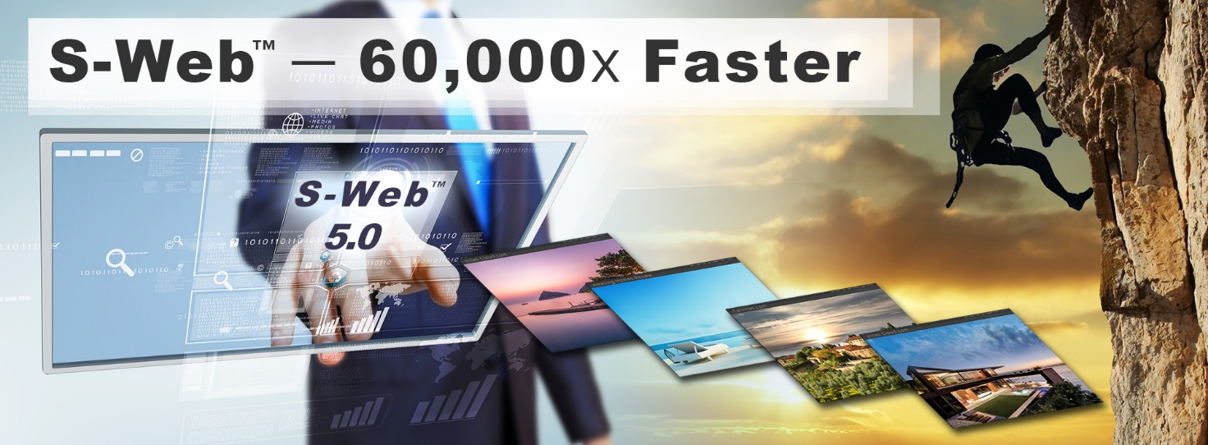
To understand the 60,000x claim we start with an absurdly ambitious but theoretically achievable objective, noting that the S-World AI macro technologies 7, 8 and 9 present an economic yield for developing nations of $1039 trillion if the underlying assumptions are correct.
The underlying assumptions are the 10 technologies that make up S-World AI, of which S-Web is technology 1.
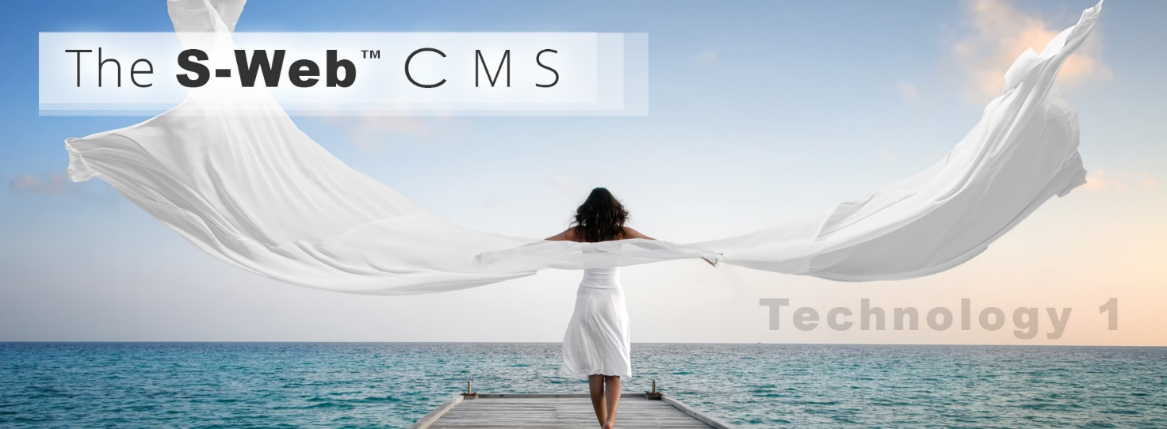
With that clarified let us begin with the revenue objective created to illustrate T1. S-Web’s more than 60,000x ability to create web and app platforms for S-Word AI’s network companies.

Revenue Objective — $0.77 Trillion p/a
S-World AI revenue of $0.77 trillion per year — is close to the S-World AI 12-year profit forecast for VIRGIN in 2011. Before I was curtailed, and some may argue advanced by the story told in The Unbreakable Trilogy.
The simple math behind this objective is — to create 15 billion websites or apps generating on average $1,000 p/a with a 2.5% service, franchise, and ongoing development fee = $0.77 trillion p/a.
The complete S-World Platform is at play but in this exercise, we are paying particular attention to the first of the 10 technologies. T1. S-Web.
The objective is not to make a system like WordPress that is 60,000x faster for the user, the objective is to create a network of websites 60,000x faster for the supplier (S-World AI’s) Network — this is loosely demonstrated in the 60,000x faster videos. It requires this infra spec, and the S-Web 5.3 shared menus function.
Adding APIs from other AI systems like ChatGPT and Aious can make S-Web and The S-World Platform significantly more effective than was originally considered.
Noting that for a decade the missing piece of the puzzle was T10 S-World Angelwing — the combinatorial explosion technologies 1 to 9 integrated with other companies’ AI’s.
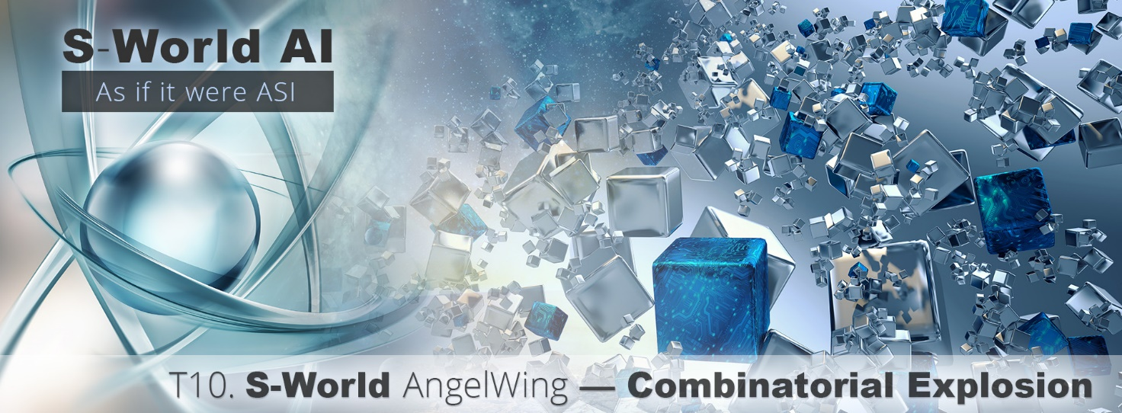

Must Adapt to all industries.
Since 2009 we have shown S-Web develop in the real estate and travel industries which is about 20% of the world's revenue. Note it’s more accurate to use global revenue than GDP as GDP only applies to new build real estate.
The original 2011 plan for VIRGIN pivoted on the idea that the Network must adapt to all industries. Since then, we have done just that, from film and media to books, even tax government collection, and since 2017 and the advancement of the macro technologies 7, 8 and 9 we theoretically extend to the creation of everything from food and medicine to high-speed rail and shiny new aircraft carriers.
See Books: A More Creative Capitalism, 64 Reasons Why and S-RES and The City.
But to refocus on S-Web and the S-World Platform, let's look at the most recent industry focus, whilst this technology sits within T2. Total Business Systems, the plan presented below relies heavily on T1. S-Web for its financial success.

The TLS — Total Legal System
For more details see S-Web and the TLS AI,
In summary:
The TLS was deemed a necessary part of Technology 2, but as the dedicated pages for the TLS were written, and researched, a whole different animal emerged - a disruptive threat to create a million lawsuits a year for the UK National Health Service.
Of course, this design is there to highlight the dangers to the UK in this regard, but if the only way to alert danger is to make that danger, like a war game — then let the games begin.

The seed capital plan involves creating 1,000 AI-powered websites owned by different law firms or BAR-qualified individuals each specializing in one area of law, using them to take on NHS lawsuits.
With a $500,000 investment, the plan as seen shows $4 billion in annual revenue, with S-World AI receiving 2.5% of the revenue.
A Series C investment of $100 million — broadly in S-Word, not AI not the TLS would enable S-Web sites to be given to all areas of law, potentially resulting in 100 million users globally. The plan aims to show the government the potential threat AI poses and at the same time flip that to show how S-World AI can create extraordinarily efficient government systems in all areas, with a focus on economic growth and the need for government systems to adapt to the changing landscape.


S-World Villa Secrets — Cape Villas.com
Having presented S-Web adapting to other industries, we return to its parent industry of Travel and Real Estate and the first S-World company CapeVillas.com, founded by Nick Raymond Ball in 2000. Then we jump forward 17 years to the 355-page 2017 business plan, adding all advances created since.
Unfortunately, due to the events described in The Unbreakable Trilogy — Incendiary, 2016 to 2022, the staff used this business plan to take over Cape Villas which was of course a major contributor to the need for legal research and the TLS. But now the enthralling story within Incendiary is over, it’s back to business.
Let’s consider Airbnb as a potential collaborator or competitor, and whilst it may seem a David vs Goliath battle disruption is necessary. If S-Web were to make 10 times the number of websites and apps as in the TLS example (10 times as real estate and travel has 10 times the revenue) we would be looking at a max of one billion users globally.
Remember that many users are either generic S-Web users reselling all products and services, or specialists in other industries that can resell all S-World Network products and services when the opportunity arises.
Thus, in this macroeconomic case, we see the need for S-Web to be able to make these websites and apps, at lightning speed.

60,000x Faster
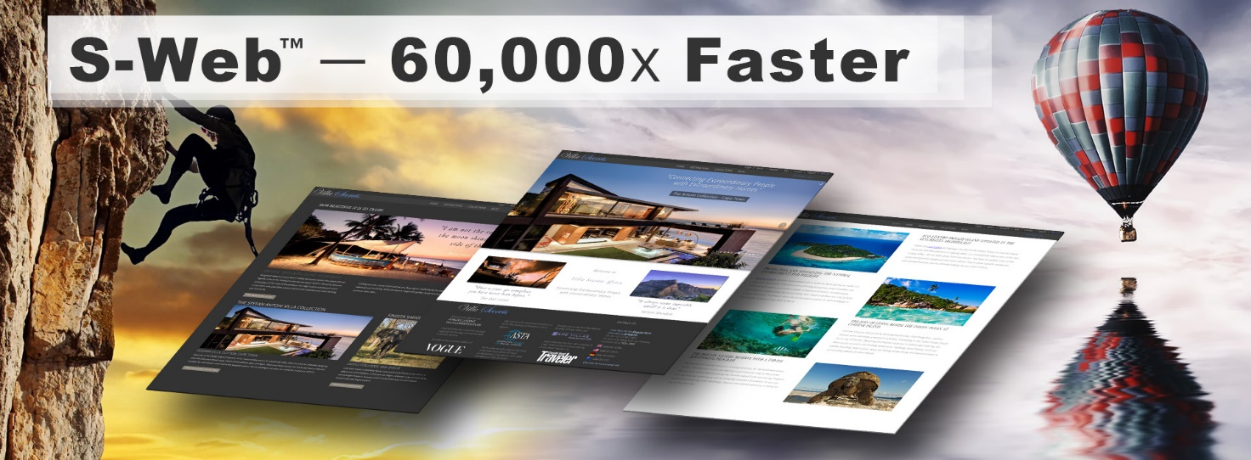
We use the 60,000x example as this was the benchmark set in early 2022, the actual speed of the fully developed T1. S-Web spec in March 2023, given API connections to other AIs such as ChatGPT and Axios and OSS databases like Cassandra and Postgres — data processing frameworks like Apache Spark — RPC libraries like OkHttp and Jersey — and frontend libraries like React.
These advances aside, a cornerstone of S-Web is that it was designed for the lowest paid or most underused member or staff, or any child over 6 to create landing and important pages, as quickly and as well, as a top-rated professional WordPress user.
Consider the homepage of a website as a sports car, it looks good, but to win the race what matters is beneath the bonnet. In that respect, S-Web is Lamborghini on steroids, designed to work with the other technologies.
Take analytics for example. If you’re paying to advertise Google Analytics can tell you which search term led to someone enquiring, but it can't tell you which search term led to a big sale, and which led to a waste of time. For that, you need to marry the website with accounting software and a CRM.
Sure, Salesforce and others have basic website tools, but good luck with that! S-Web is the Lamborghini and on top sits T2. Total Business System, designed to cut out 99% of the clutter, and in place is the Company Controller and on top of that is the TBS-CC OKRs, designed to maximize the productivity of each team member.
In some versions, it combines with T6. UCS turns each working day into a game that is scored by key results towards objectives achieved — and at the end of the day, the top scorers win from a pool of half of all salaries and bonuses.
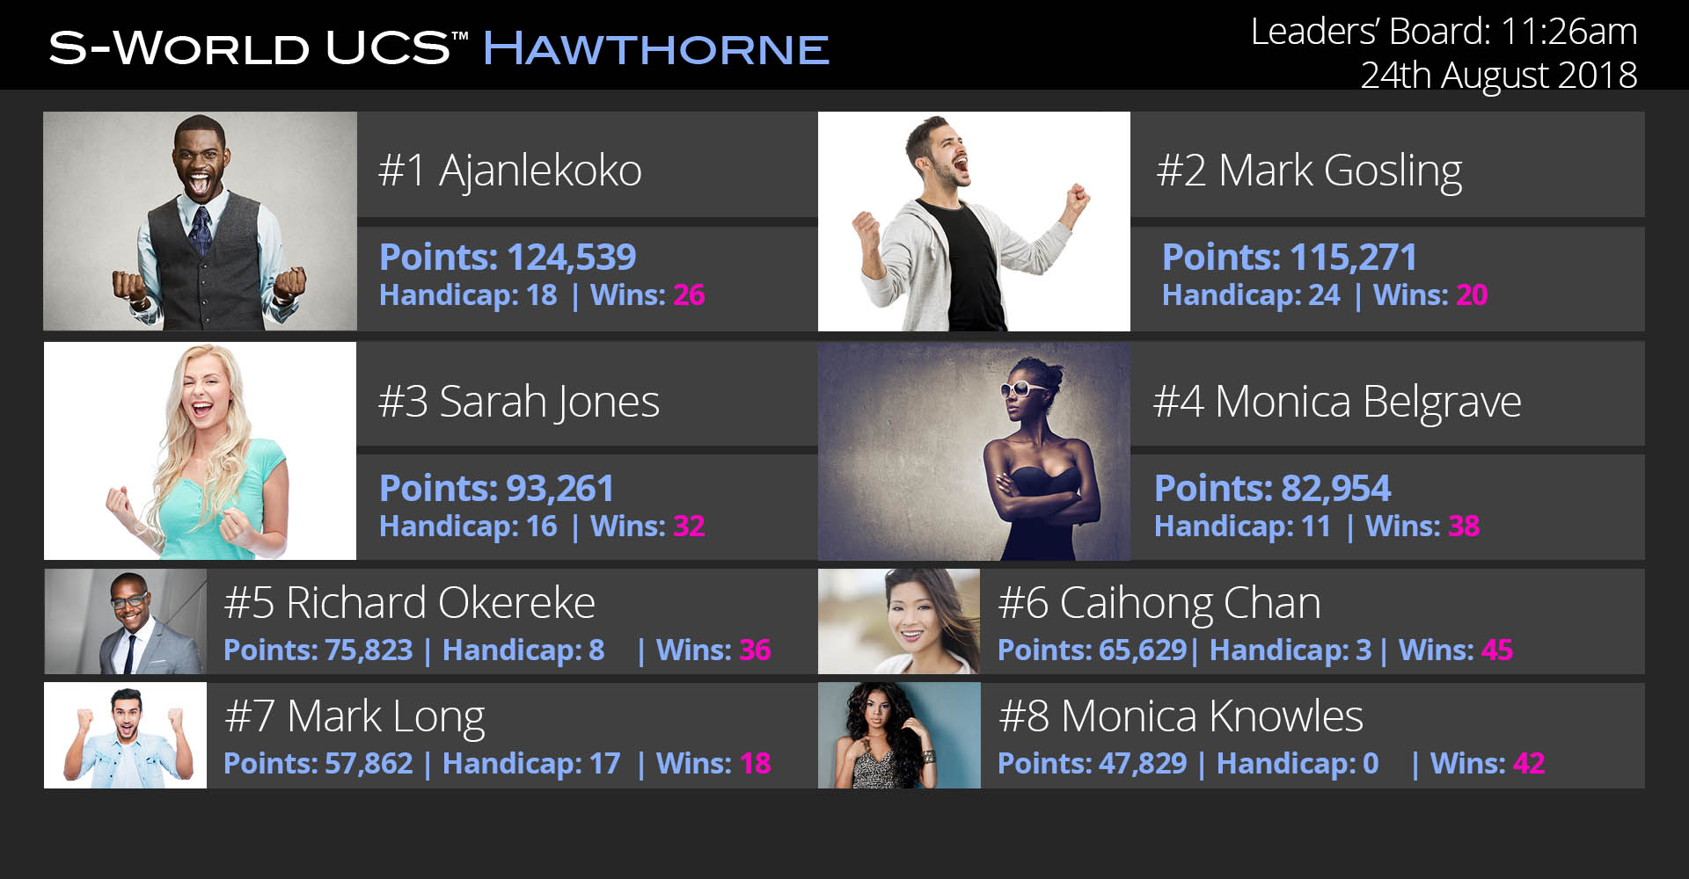
We call this UCS Hawthorne. It’s ingenious, in a sales environment and for fun one day we even adapted it to improve the catastrophic inefficiencies in the UK tax collection service HMRC.

S-Web is marred by all other technologies, which were built upon its foundation, the website, finance, marketing, legal, and everything else, are entangled.
In 2015, whilst working on what is now the T2. TBS Nudge AI, it was realised that the initial plan to connect to a host of other software was unworkable. The entire design was torn apart and rebuilt around one common API factor — Price.

In August 2022, this decision led to a mind-blowing development for the macro technology T7. S-RES, which saw the end of the inflation problem in advanced economies. But let us save that for another day.

Thus, the entire website itself, with all the APIs and products and updates with fresh content rewritten with API panache tailored to the exact audience of the user, translated into whatever languages they may use, sometimes multiped into different websites for each language, for example, this prototype translated into German. Is created not 60,000x faster but using the infra script within milliseconds. All that is left to do, is for the owner of the websites, to either use the homepage maker tool as seen on the 60,000x videos, to create their homepage to their like, or get any staff member with an hour to spare or their 6-year-old child to do it for them.

Define S-Web's 60,000 Times Faster Claim
Returning to the Define S-Web's 60,000 Times Faster Claim, I hope we now see that while our initial presentation may have given the impression that the homepage maker CMS was 60,000x faster than WordPress — What was being highlighted was the ability to create everything except for the homepage, whereafter due to the simplicity of the S-Web homepage (or any other page) maker CMS (Content Management System) the user, no matter what their skill set, can easily create the homepage themselves.
At the time we measured this as 60,000x faster, but now, if we can get the API connections to the aforementioned AIs and databases, create that infra spec and perfect the sharing menu's function. S-Web could create those billion websites far quicker than anyone development company could create just one copy of CapeVillas.com, so that 60,000x would be 1,000,0000,000x faster.

1,000,0000,000x faster.
If in collaboration with Airbnb which is realistic as the first VC on our list is Founders Fund which owns equity in Airbnb, each of its listings can have its own site that can if desired select other properties to resell on Airbnb.
Alternately or in parallel, we return to the rudely interrupted 2017/18 Villa Secrets; Secret plan and adapt the system for property sales, with every realtor or property owner on the planet creating a site for each property, which can also present a million, other options to clients.
Moving from real estate to travel using the first ever S-Web website Experience Africa as an example, as far back as 2009 Sotheby’s International Realty saw value in paying for an S-Web copy of this site called African Concierge, from which they would book their clients into Villas and Safaris.
If Sotheby’s International Realty would see this potential, so would every travel agent on the planet, and at the touch of a button, hey presto they have their unique customised website, specializing in an area that they have the occasions request for but don’t see value in spending the money on a new brand and website and even if they did, what about the clients experience at the other end.
This last question ‘the client’s experience’ jumps are answered by Technology 3. Networks Distribution, and Technology 4. S-World Film — The famous Concierge, and all the admin and legalities are handled by Technology 2. Total Business System including the TLS Total Legal System and the offensive version of the TLS-W Weapon.

Marketing
In terms of marketing, there is a very strong SEO, SEM syndication and affiliate marketing capability within S-Web, however, these capabilities are mostly actioned in technology 3. Networks Distribution. However, it is worth mentioning that Cape Villas was initially so successful in the early 2000s due to its VR.
Whilst the technology is different and must be either built from scratch or customised via a deal with Meta, the VR plans for S-World AI, are considerable and are expressed in theory in Technology 6. S-World VN. Virtual Network, noting that the very name S-World is an abbreviation of Sienna’s Word.
Sienna is the daughter of founder Nick Raymond Ball and sadly but not if one is deeply spiritual and is an ASI designer, the World in S-World is a Virtual World design not dissimilar to The Metaverse, but an almost exact copy of the real world we see today, and within this world, Sienna or as realistic an AI copy of Sienna as can be created, could get to live the life she did not have the chance to lead.
We can see some early development of this concept in American Butterfly Book 1. Chapter 7. S-World.
On this point skipping forward from 2012 to 2022, I saw a tweet from Elon Musk just a few days back, “I used to be in crypto, but now I got interested in AI" This reminded me of an earlier quote I remember from him ‘I hope they’re nice to us?
My answer was and still is that if AI is created with the simple motive as presented above and for some reason becomes so advanced it is classed ASI, then we should all hope that S-World AI and Sienna are that ASI.
With that little history lesson and a glimpse of the future presented, if we look back again to 2012 and this time the final chapter of American Butterfly book 1. The Theory of Every Business Chapter 8. S-World UCS we are introduced as the Network as a game.
Collectively these two chapters were the beginning of the story of technology 5 S-World VSN and Technology 6. S-World UCS.
These technologies have advanced a lot over the past decade, into T6. UCS Histories — the simulation that created the $1039 trillion for poor and developing countries that we heard about at the beginning, and T5. VSN Construct/Dreamscape Basic is the technology that addresses those underlying assumptions.
But backtracking to the Marketing question, S-Web is a framework that has been constructed for T3. Networks Distribution to monetize, the basic VSN model of

Chat GPT Longer Summary
For more details see S-Web and the TLS AI, In summary:
The seed capital stage involves creating 1,000 websites owned by law firms specializing in one area of law, using AI to take on NHS lawsuits, and presenting all correspondence on the websites and social media platforms. This process enhances the S-Web Long Tail Keyword SEO by creating relevant content that increases the long tail keyword search results for that phrase. The websites then cross-link with other regional websites, potentially creating many lawsuits and generating billions of pounds in revenue, with S-World AI receiving 2.5% of the revenue.
Assuming it takes the government five years to adapt and pass laws to stop the AI legal attack plan, a $500,000 investment could generate $4 billion in annual revenue, with S-World AI receiving 2.5% ($25 million per year) for five years, resulting in a ROI of 250:1. Additionally, the system will have adapted to the new laws and can continue to improve and expand into other areas, including private health companies, pharmaceutical companies, medical equipment companies, and care companies.
With a Series C investment of $100 million, S-Web sites can be given to all areas of law, including the 220,864 solicitors in the UK, students, and staff, making it at least 100 million users globally. While some may make over $1000, others will make many millions of dollars, and some will make no money but will help in recruiting clients for the main law firm.
This plan was made in 7 days and includes the S-Web and S-World Virtual Network. The end goal is to show the government the potential threat AI poses and create government systems. There are failings in the legal system and the NHS, which is outlined in The Benefits Trap economic paper.
S-Web could potentially lead to 100 million websites in the law industry and expand to other revenue sources, resulting in more than 15 billion websites and apps. The focus is on the potential for economic growth and the need for government systems to adapt to the changing landscape.
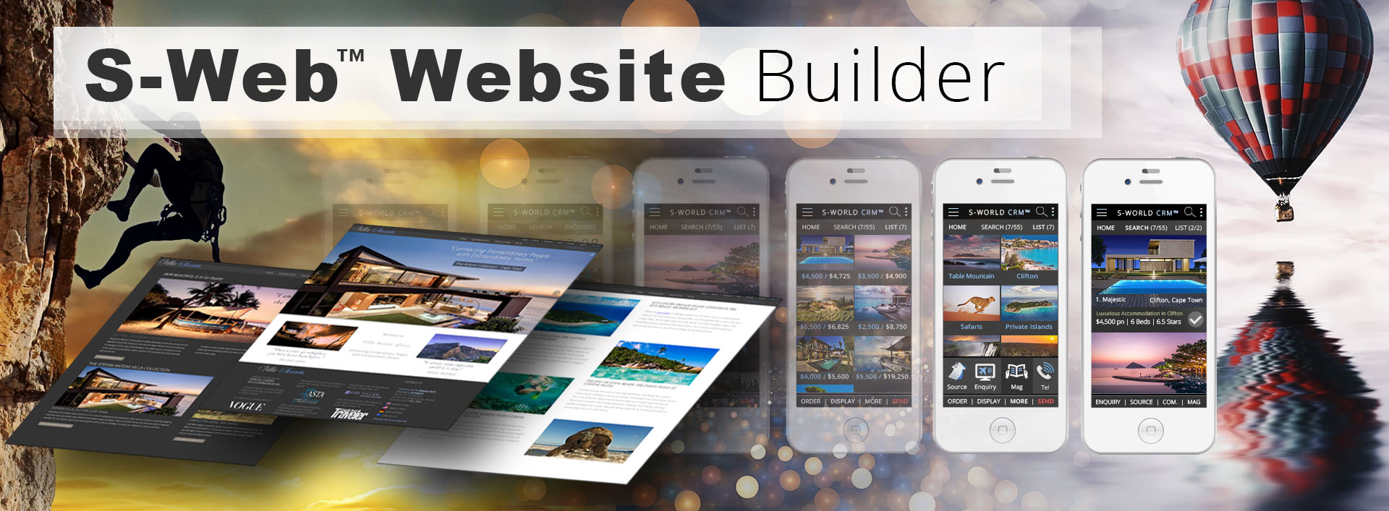

S-Web Creates Websites 60,000 Times Faster!
16.22b.1) S-Web Creates Websites 60,000 Times Faster! (20 Feb 2023)
By Nick Ray Ball

Monday – 00.34 GMT – March 07, 2023
Continued in the morning with ChatGPT assistance


In terms of completing this quickly, bringing this to market — creating lucrative collaborations or where such collaboration is not in our interest outperforming/disrupting/dominating other niches, but unlike WordPress, it being not profited absurdly profitable as part of S-World AI – AS if it were ASI.
This is that venture that The PayPal Mafia a16z and What Matters will throw money at.
But you need to understand its purpose if you wish to understand the 60,000x.

It's not 60,000 faster for an individual, it's faster, but not that fast. It is, however — It’s more than 60,000 times fast for the needs of Villa Secrets and S-World AI

Considering just two major prototype industries real estate and travel, that’s about 20% of global cash flow. And our newest interpretation when it entangles with The S-World Business Platform (T1, T2, T3 and T4) with the latest T2. TLS AI (Total Legal System).

This is itself an evolution, as we desire an API with Chat GDP (now Microsoft) and the Smart Brevity AI. The plan is currently in a long format and can go one of two ways, it can make the most devastating attack on the legal system, taking out the NHS, and forcing 98% of establishment magistrates to quit. As a warning of what others not that far behind could do.

Then use that warning to flip it to defend against such future AI attacks, floorless. And add such efficiency cutting personnel duties by more than half and increasing their efficiency in ways, that would see The Secret Barrister cry a sigh of relief.
But as you will see in that example, we can start with 1000 sites in the UK, but quickly move to 100,000 one for each law firm or law graduate and then there’s the US, Africa, Europe and the rest of the world. So let us say we need a few million websites. Or 10x if each user were to have multiple speciality websites. So, we're taking about 30 million. In just one field – Law.

Per my can make $1 trillion in 12 years if it can be adapted to every industry, for Virgin in April 2011. Don’t focus on the trillion, focus on every industry, and there are many other examples from HMRC, to the Media, from authors to Movie companies, at least 512 different niches, some requiring more sites and apps, some less but globally about 15 billion. If each makes $10,000 that’s $150 trillion in revenue, and if S-World AI were to collect 0.5% then that $750 billion which is there or thereabouts the same as that original Virgin estimate, however, who is to say we can't take 2.5% thus $7.75 trillion in S-World AI Revenue. Network revenue of £150 Trillion, S-World AI revenue of $7.75 trillion per year.

In all industries, we have at least 15 billion websites, As of September 2021, WordPress has a market share of approximately 42% of all websites on the internet. It is difficult to provide an exact number of WordPress websites as the platform is open source, meaning anyone can download, use, and customize it without registering their website. However, according to recent statistics, there are currently over 455 million websites using WordPress.
This means WordPress would have but 3% of what S-Web however Chat GPT says:
As of September 2021, there are over 1.9 billion websites in the world.
Which makes WordPress 42% incorrect. But if we take our 15 billion S-Web sites and divide by 1.9 billion and add say another billion for 1.1 billion for 4 years making 3 billion in 2027 S-Web would have 80% of the global market. But whereas many websites will be making little money, all S-Web sites will be making money.
Of course, we come back to the ease of making websites, and that 60,000x figure of us creating the websites that are so easy to use that the user's lowest paid staff member or their kid, or themselves can create, then we understand that 60,000x power, for S-World AI, not the individual user.

We can make the new themed websites in under 6 seconds, and because the customization is so easy and the content swapping menus, updated by ChatGPT SMART Brevity and other content-based AI, plus of course the T4 video and photos platform, each with its owner Google My Business address, or if under 18 just an address and a great many referring links from regulatory bodies.

I asked ChatGPT to surmise and it gave me.

The text discusses a venture that aims to create lucrative collaborations or dominate other niches, but not profit absurdly like WordPress. The venture is expected to be funded by The PayPal Mafia, a16z, and What Matters. It is said to be 60,000 times faster than Villa Secrets and S-World AI, which represents more than 20% of global cash flow in the real estate and travel industries. The plan involves an API with Chat GDP Smart Brevity AI and a TLS AI that could make a devastating attack on the legal system. The goal is to cut personnel duties by more than half and increase efficiency. The plan could involve creating millions of websites, generating $150 trillion in revenue if each site makes $10,000. S-World AI could collect 0.5-2.5% of this revenue. WordPress has a market share of approximately 42% of all websites, but S-Web is expected to have 80% of the global market by 2027. The ease of creating websites is emphasized, with new themed websites created in under 6 seconds and customization made easy with the help of AI.

I’m manually correcting it to
Second regeneration
2 / 2
The text discusses a venture that is seeking to create lucrative collaborations and outperform other niches, to generate revenue from a large number of websites across various industries. The venture's ultimate goal is to adapt to every industry and potentially generate trillions in revenue by making the creation of websites and customization easy for users. The text also discusses the potential impact of AI on legal systems and the potential for creating a large number of websites within the legal industry. The author suggests that S-World AI has the potential to dominate the market, potentially capturing 80% of the global market by 2027. The focus is on generating revenue from each website and making customization easy for users.

S-Web Creates Websites 60,000 Times Faster!
16.22b) S-Web Creates Websites 60,000 Times Faster! (20 Feb 2023)
By Nick Ray Ball

Monday – 08.20 GMT – February 20, 2023

The S-Web CMS (will be) 60,000 times faster than WordPress — and WordPress makes more than 40% of the world's websites.
It's so simple to use, the lowest-paid member of any company — intern, janitor, or receptionist can compete with Silicon Valley’s best web design professionals. See these simple tutorial videos for proof of this concept.
It matters because S-World AI is seeking AGI (As to ASI
AGI to ASI benchmarks in all key areas— As if it were
at making API-driven websites like www.CapeVillas.com — Noting that WordPress makes more than 40% of the world's websites.

It matters because climate change, economic migration, poverty, and overpopulation are real, but without a solution. — Only a human-assisted ASI-like technology can fix this.
These problems are not of our making — but as we have the capacity, we are going to help.
Unlike traditional work in AI, S-World AI is designed to provide the average human, the ability to match the best specialists on the planet.
If we took away the human — they would call this AGI — Artificial General Intelligence.
If we then gave these average humans, the ability to match the best — but do so — 60,000 times faster – That’s ASI.

For an example of this in one small but important area — making websites see www.S-Web.org. For how to apply HA ASI (human Assisted ASI) to say construction see www.S-World-VSN.com
For the bigger picture, how we can 32x the amount of money, and zero out inflation see www.S-World.org
This website also tells of the Climate Change solutions, poverty, economic migration, overpopulation and a further 60 solutions to major problems.

See you there soon.

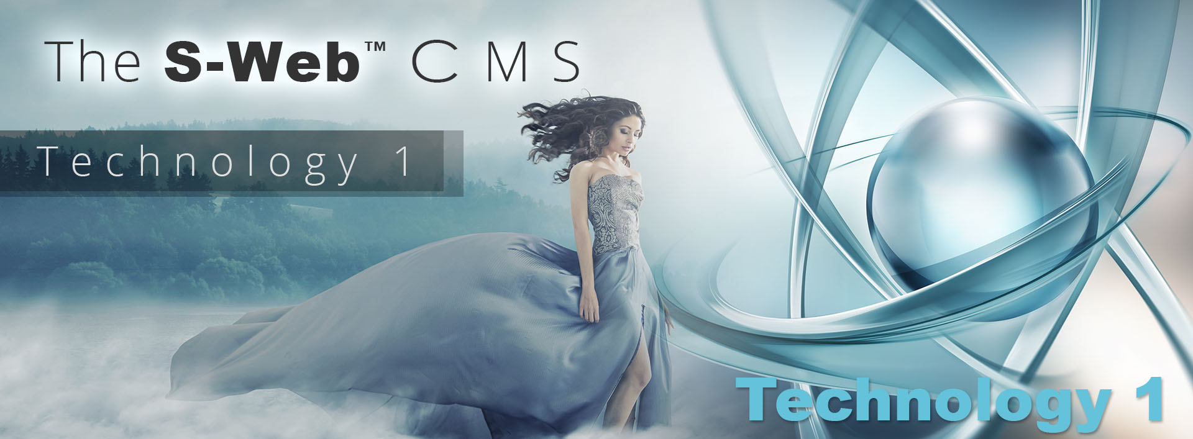

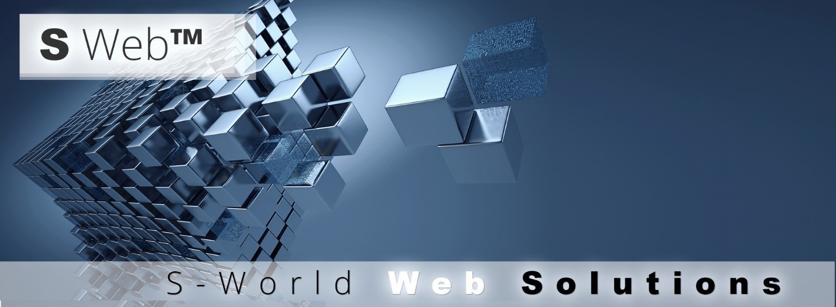

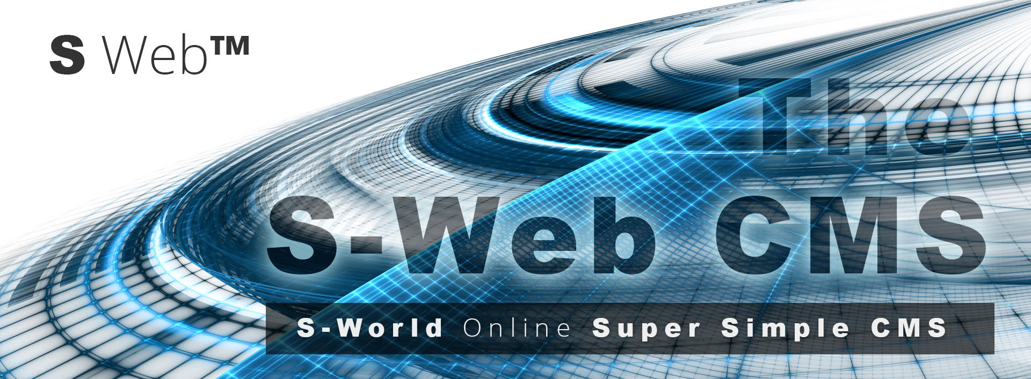

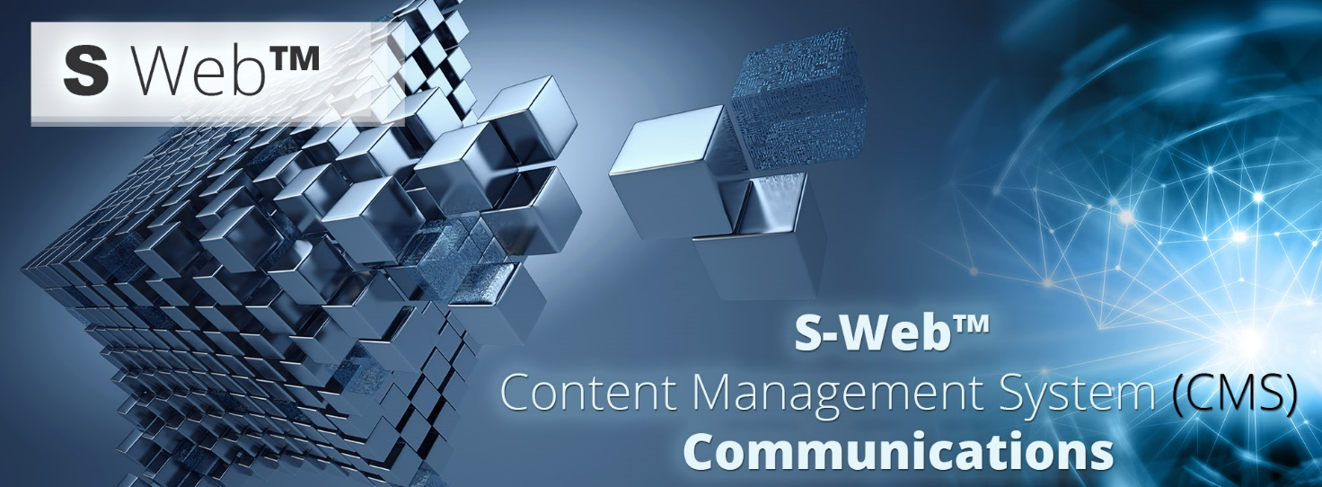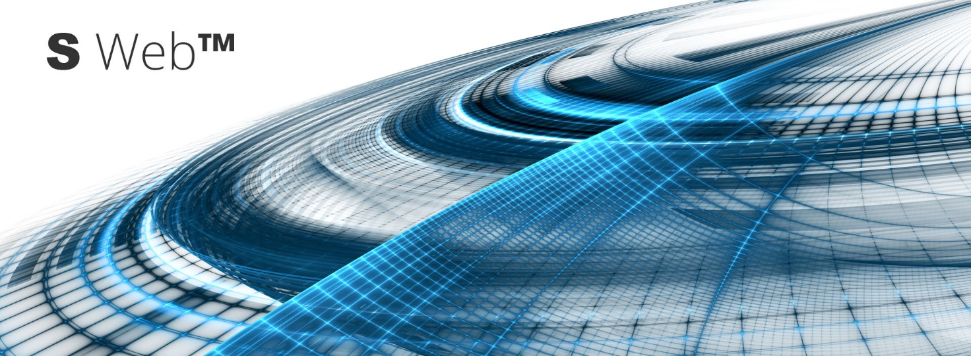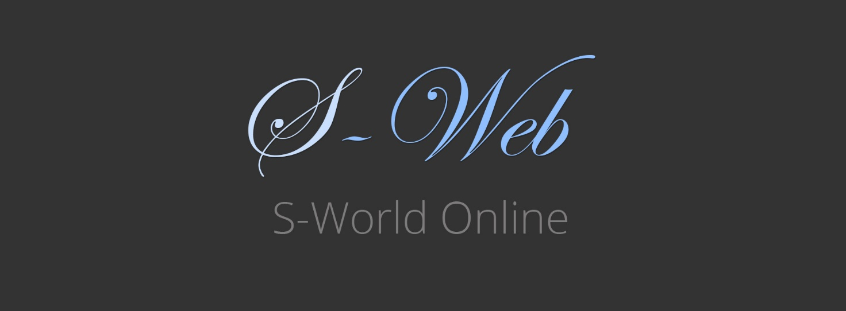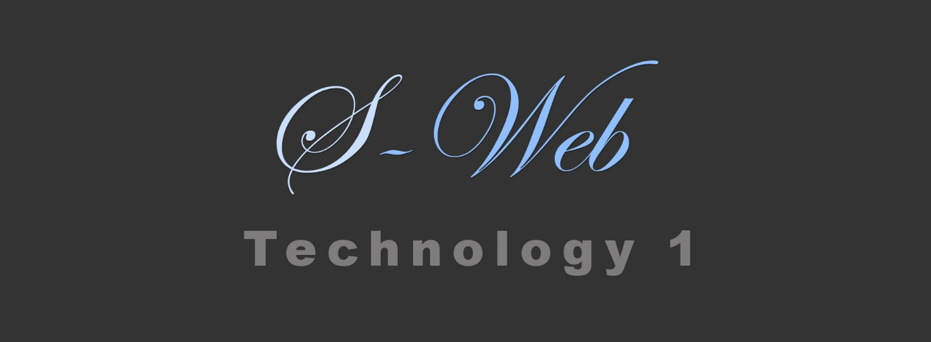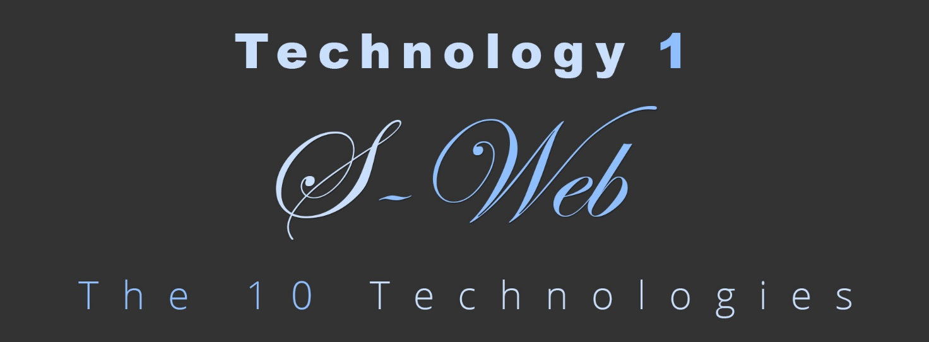

S-World AI™ by Nick Ray Ball
2000 to 2023

S-World AI — ‘As if it were’ — ASI.

Nick Ray Ball
Contact
+44 7387 394 298
Nick@NickRayBall.com
Media
https://Twitter.com/NickRayBall
Facebook.com/NickRayBall
https://www.Linkedin.com/in/Nick-Ray-Ball
Websites:
www.The10Technoogies.com
www.S-World.org (+ 11 others) (2021 2023)
www.CapeVillas.com (+19 others) (2000 to 2023)
www.AmericanButterfly.org (2012)
www.AngelTheory.org (2017)
www.Supereconomics.ai (2021)

